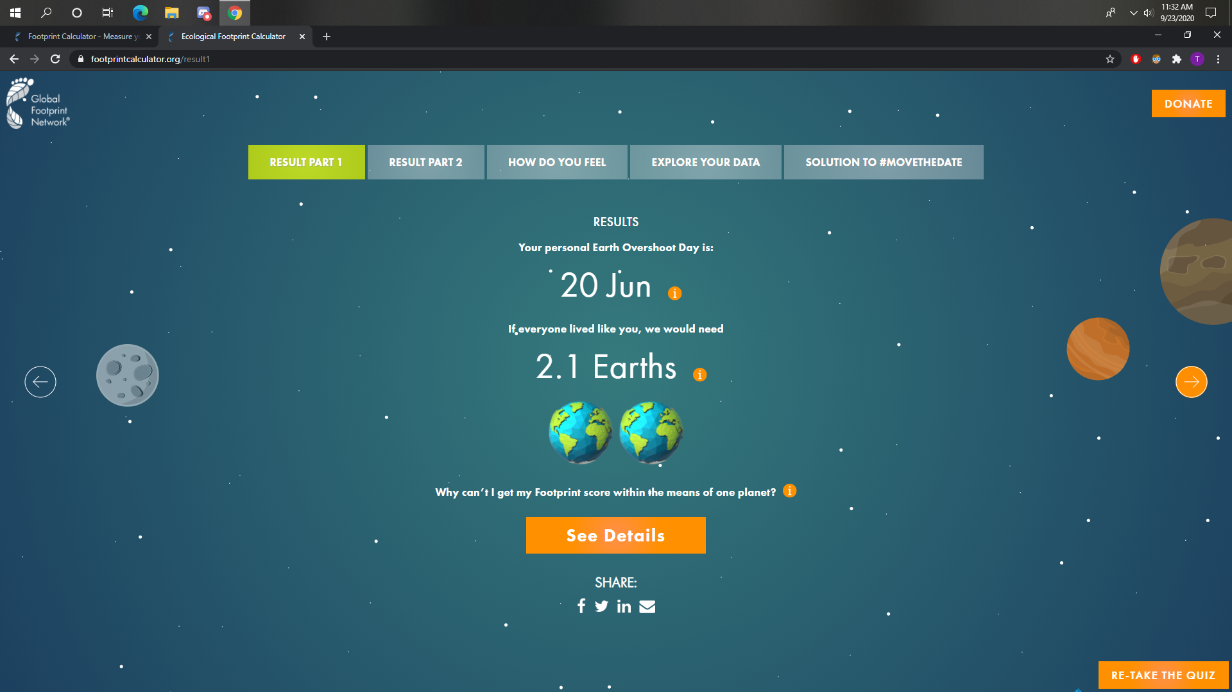

In order to lower my ecological footprint, I could grow my own fruits and vegetables in my backyard so that I would have unprocessed and locally grown food available. Another thing I could do is cut down on my meat consumption by switching to alternative protein foods like tofu.

Earth Overshoot Day is the day that is marked when the demand for ecological resources and services in a given year exceeds what the Earth can regenerate that year. The Day keeps getting earlier every year because humanity is overusing the Earth’s resources to the point where it is sustainable.